**Survey Settings- REDCap – How-To Guide**

# Enable Survey

You can enable any instrument as a survey and then collect data for that instrument from survey respondents. The only difference between an instrument and a survey is who will be entering the data: project users, survey participants, or both.

For surveys, you may utilise a Participant List for emailing your recipients and to track who has taken your survey(s). And if your first data collection is enabled as a survey, then you may use a public survey link, which is a single link that can be emailed to all participants or even posted on a website.

▪ Go to **Project Setup**



▪ In the top box **Main Project Settings** click **Enable** Use surveys in this project?

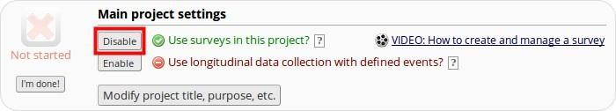

▪ Next click on **Online Designer**

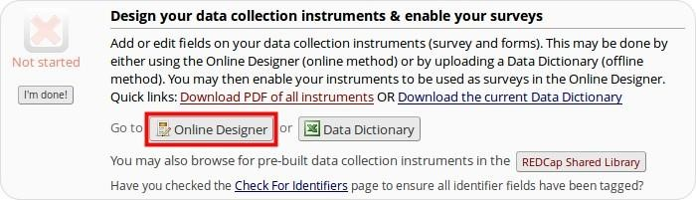

▪ Select **Enable** for the forms you want to use as surveys.

# Survey Settings

Once you enable your data collection instrument as a survey, the “Survey Settings” page will appear.

You can make changes to Survey Settings at any time. To get to the Survey Settings click on the Designer link on the left-hand navigation bar under Project Home and Design.

## Survey Status

A survey can be Active (online) or Inactive (offline). The default setting is online

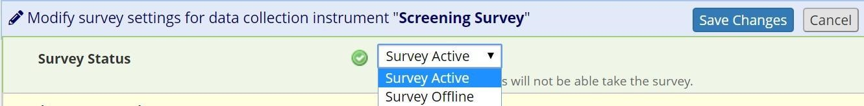

## Basic Survey Options in Survey Settings

**Survey Title:** The default survey title is the name of the instrument. However, your survey title does not have to be the same name as your instrument. You can change the title here in Survey Settings.

**Survey Instructions:** Enter any instructions you wish to give to the participant. The default instructions are “Please complete the survey below. Thank You!” Oftentimes it is helpful to include a contact email address if the person has questions or the deadline by when you need them to complete the survey.

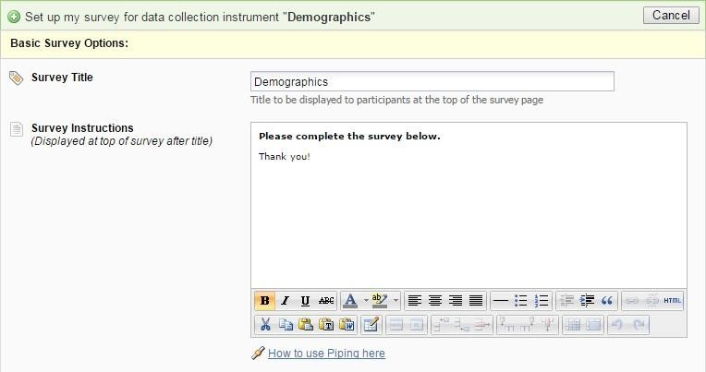

## Survey Design Options

**Logo:** Click the Choose File icon and add a logo.

**Size of survey text:** Use the drop down and select Normal, Large or Very Large.

**Font of survey text:** Use the drop down and select the font family you would like to use.

**Survey Theme:** Use the drop down to select a saved survey theme, including a CMH survey theme. Otherwise you may click Customize and change the color of your backgrounds, fonts and buttons. If you would like to use the same color choices at a later date, click the Save custom theme icon.

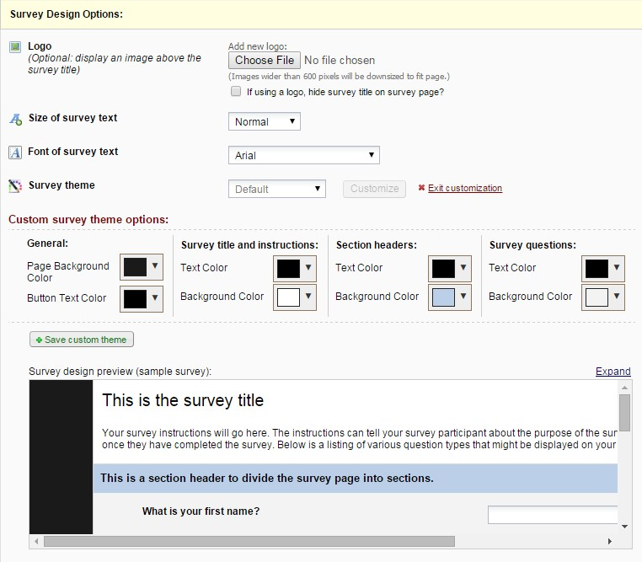

### Survey Customizations in Survey Settings

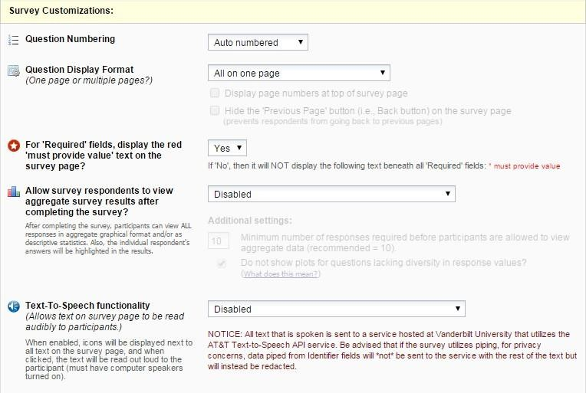

## Question Numbering

REDCap will by default auto number survey questions. The exception is if you have branching logic in your survey. In that case, auto-numbering is disabled and instead your questions are custom-numbered.

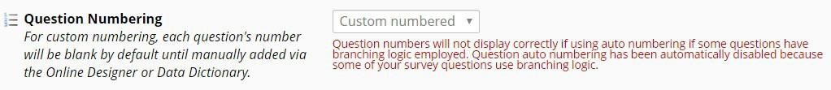

## Custom numbering of questions in Survey

If you change the setting to custom numbering, question numbers will be removed. If you set your Survey Settings so that your questions are custom numbered, you will see a ‘Question Number’ box for each field of that survey in Online Designer:

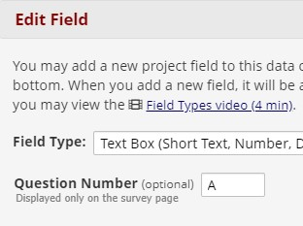

You can enter your custom question number there (or leave it blank.)

## Question Display Format in Survey Settings

**All on one page:** Select this if you would like all of your questions placed on one page.

**One section per page (multiple pages):** Select this option if you would like to like to break your survey up into sections by your section headers (the yellow banner bars). If you select this option, you can display the page numbers at the top of the survey page and also hide the “Previous Page button”.

## Survey Design Tip: Using Descriptive Text field as a section sub-heading

If you want to break up the content of the survey page but don’t want the participant to have to go to a new page (which is what a ‘Begin New Section’ field type will cause), use the descriptive text field instead.

For example, using html coding you could type this as your field label:

<div class="blue" style="font-weight:bold;">A descriptive text field used as a sub-heading</div>

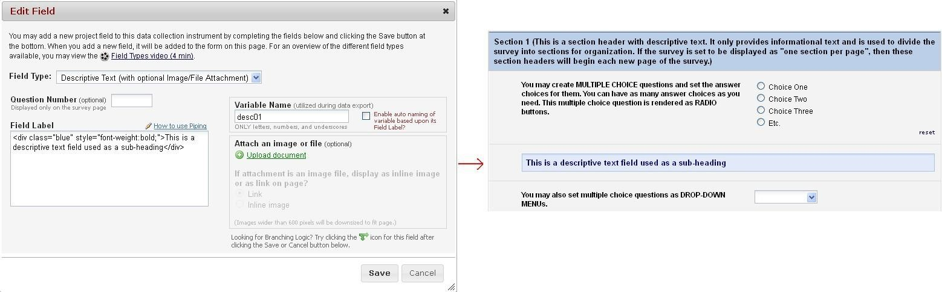

**Allow participants to download a PDF of their responses at end of survey?**

The default setting is no.

The respondent will see a PDF button on the confirmation screen (screen they see after they hit the survey submit button).

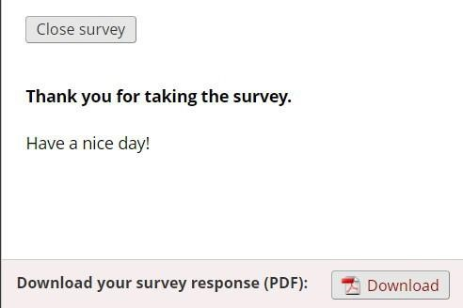

All fields viewable to the survey respondent on the screen, regardless of whether or not they answered the question, are included in the PDF. This means that if a HIDDEN action tag is used on a field in the survey, that field will not be visible in the PDF.

Exceptions: This option is not available if the Survey Auto-continue feature is enabled or if the Survey queue auto-start option is enabled.

## Survey-specific email invitation field in Survey Settings

You may have a project with multiple surveys where different people are completing the survey for the same record. If you wish to designate which person should be sent the invitation for that specific survey, you would select that designated email field from the drop-down list.

Note: only text box fields that have been validated as an email address show up on the drop-down list.

## For “Required” fields, display the red ‘must provide value’ text on the survey page

The default setting is Yes. If you do not wish to have the ‘must provide value’ field display on your survey, use the drop down and select No.

# Allow survey respondents to view aggregate survey results after completing the survey

The default setting is disabled. Otherwise you may choose to display Graphical Plots, Descriptive Statistics or both plots and statistics. If you enable this setting, you can choose the minimum number of responses before participants are allowed to view the aggregate data.

## Text-To-Speech functionality

The default settings is Disabled. When enabled, icons will be displayed next to each text that is listed on the survey. When clicked, the text will be read out loud to the participant.

## Survey Access in Survey Settings

How a survey participant accesses the survey can be set in the Survey Access section of Survey Settings.

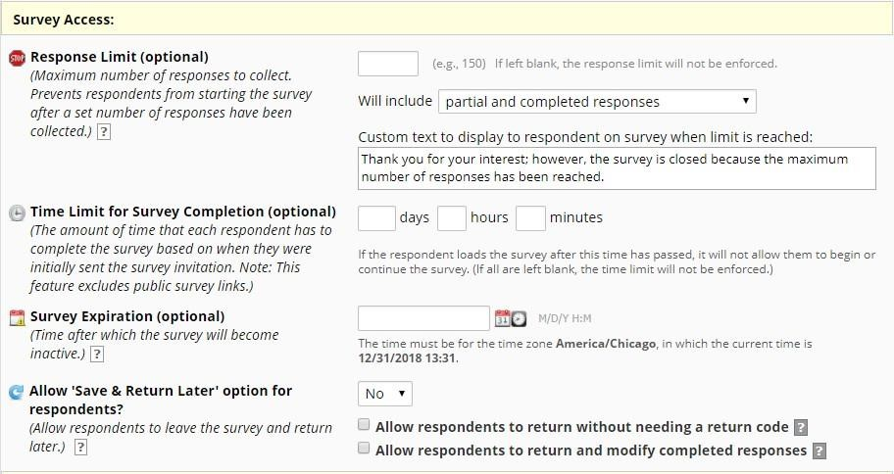

**Response Limit (optional):** Default is blank

This setting prevents respondents from starting the survey after a set number of responses have been collected. You can specify if a response is only completed responses or partial/completed responses. You can also modify the stock language that is shown when the limit is reached.

**Time Limit for Survey Completion**

You can use this setting if you wish to limit the amount of time a respondent has to complete a survey after it was sent to them.

This only works when you have a participant list – it will not work on public survey links. It’s ideal if you want to keep a survey open but will have rotating groups of people taking it.

Note: the language displayed to the participant is not customizable.

**Survey Expiration (optional):** You may enter a date/time you would like for your survey to expire. This saves you the trouble of going to survey settings and changing the survey status to inactive (especially helpful if you want the survey to go offline when you are not at work!)

**Allow ‘Save & Return Later’ (Save and Return Later) option for respondents:** You may enable this option if you would like your participants to be able to come back and finish taking their survey.

If enabled, the participant will receive a generated code they must enter in order to continue. If you want them to be able to return to the survey without needing a code, you can check that box. **NOTE: If you are collecting identifying information (e.g., PII, PHI), for privacy reasons it is HIGHLY recommended that you leave the option unchecked so as to enforce a return code.**

You may also indicate if you would like your participants to be able to return and modify their completed responses.

## Survey Termination Options in Survey Settings

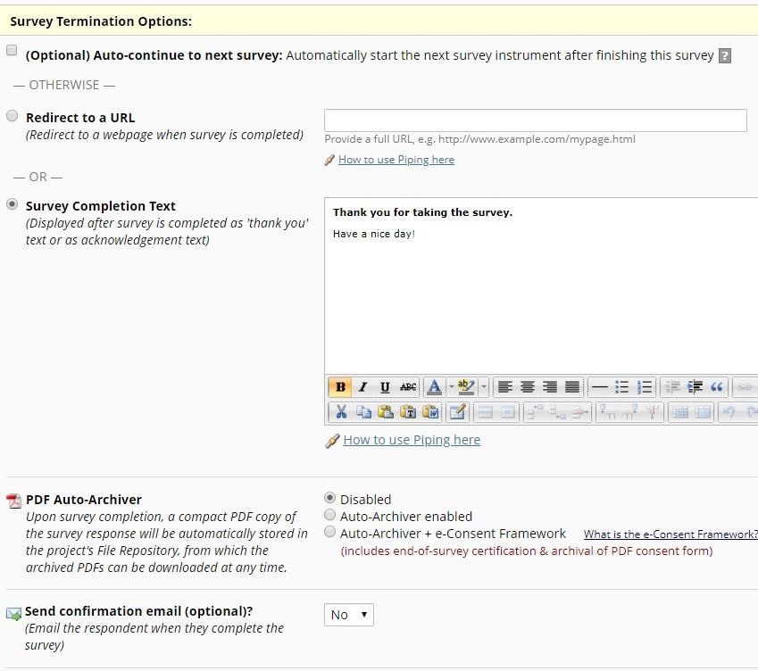

## Auto-continue to next survey

Click this if you have more than one survey and you would like the next survey to automatically start as soon as this survey is completed. If you want the respondent to complete a subsequent survey at a later time or only if they answered questions with a specific answer, then you would not want to enable this feature. See Survey Invitations for further information.

Note: if you have auto-continue enabled and then set up a Survey Queue, auto-continue is not automatically disabled. In fact, it will trump your Survey Queue settings.

## Redirect to a URL

If you would like the participant to be redirected to another URL after they have completed their survey, enter the full URL. For instance, if a person is registering for an event and you have a website for your event, you could enter that website here.

## Allow respondents to repeat the survey

If the instrument is enabled as a repeating instrument, you will see these options in the Survey Settings.

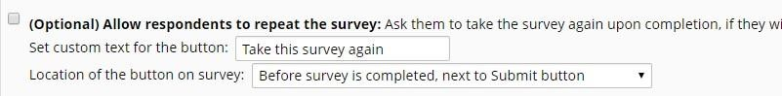

# Survey Completion Text

Enter any text you wish to display after the participant has finished taking your survey. The default text is “Thank you for taking the survey. Have a nice day!”

## PDF Auto-archiver

|  |  |
| --- | --- |
| With this setting enabled, upon survey completion, a compact PDF copy of the survey response will be |  |
| automatically stored in the project's File Repository, from which the archived PDFs can be downloaded at any time. | |

The default setting for this option is ‘no’.

# Auto-Archiver + eConsent Framework

|  |  |
| --- | --- |
| This setting not only will save the version of the completed survey to the file repository, but it will provide a |  |
| summary screen to the respondent. The respondent has to review that summary screen before clicking submit. | |

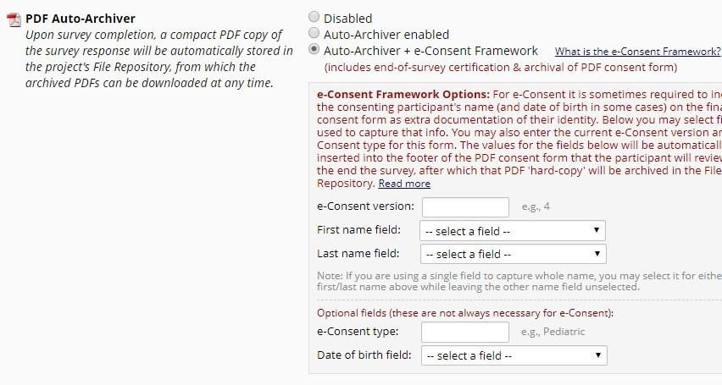

**It is highly recommended that you have a discussion with your local Institutional Review Board (IRB) if you wish to do e-Consent in REDCap.**

## Send survey confirmation email in Survey Settings

If you would like the participant to receive a confirmation email once they have completed the survey, use the drop down and select Yes. Enter the subject and the body of the message. You may also add an attachment to the email by clicking Choose File or automatically attach a PDF of the completed survey as an attachment. The PDF of the completed survey will show all the questions and choices in the survey – not just the questions and choices selected.

|  |  |
| --- | --- |
| Since email is not considered a secure form of communication, the PDF attachment option is NOT recommended if the survey contains | |
| questions asking for identifying information (e.g., PHI). |  |

If you send a confirmation email to the participant and you have the eConsent framework enabled, the participant will receive a compact version of the PDF of their survey responses. That means that they will only see the questions they answered (it will omit unanswered questions and unselected choices.)

You can use html coding in the confirmation email.

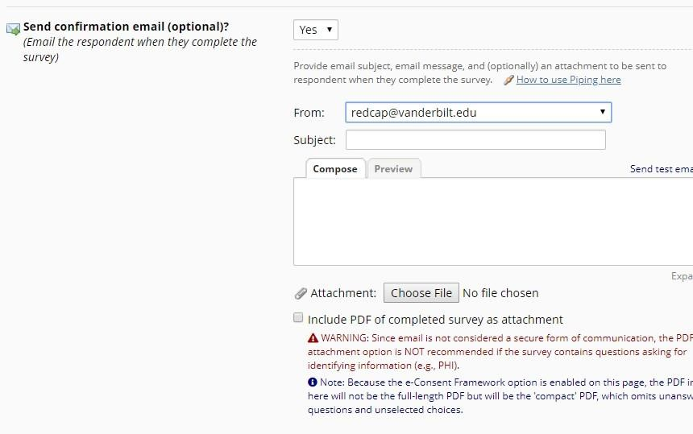

### Survey Inactive Comparison

There are several ways a survey can be taken offline. Here is a side-by-side comparison to help you choose the one that best suits your needs:

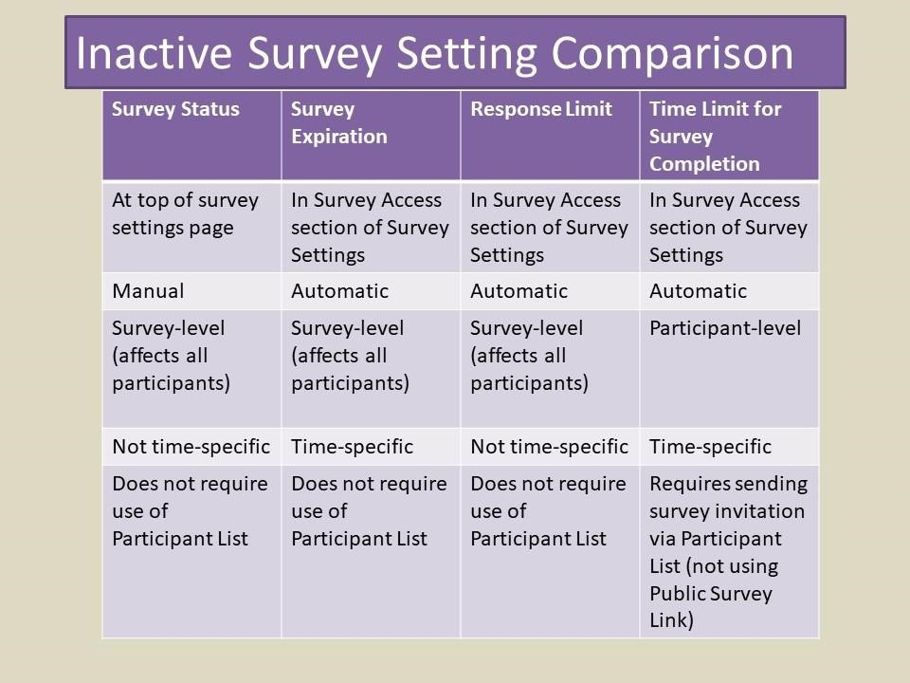

#### Best practices for Survey Settings if collecting PHI (Protected Health Information)

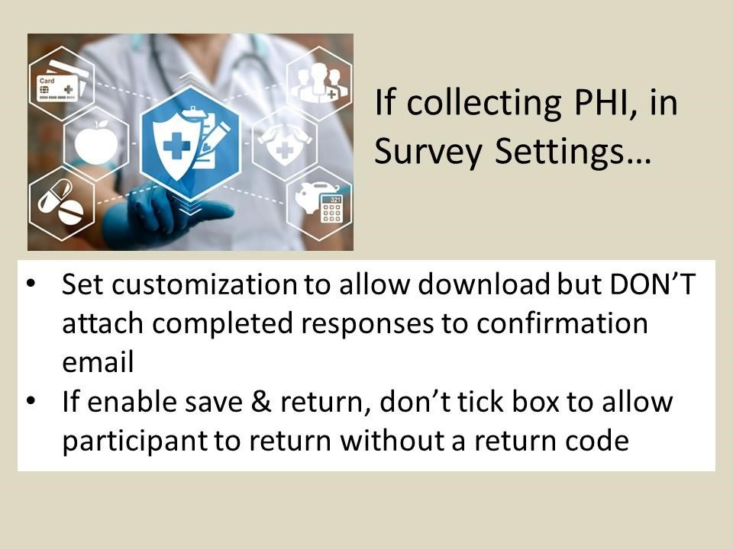

### To change an instrument from a survey back into a data entry form (reverting a survey to a data entry form)

If you have designed an instrument as a survey but want to change it back to a data entry form, go to Survey Settings (Project Setup/Online Designer) and click on the Delete Survey Settings button at the bottom of the page.

